Computer Language Coding Concepts

Symbol
The term symbol is not to be confused with the term related item or related list item. A symbol is a shape displayed on screen.

The same related item or related list item can be displayed on screen multiple times, when the parent object is displayed on screen multiple times.

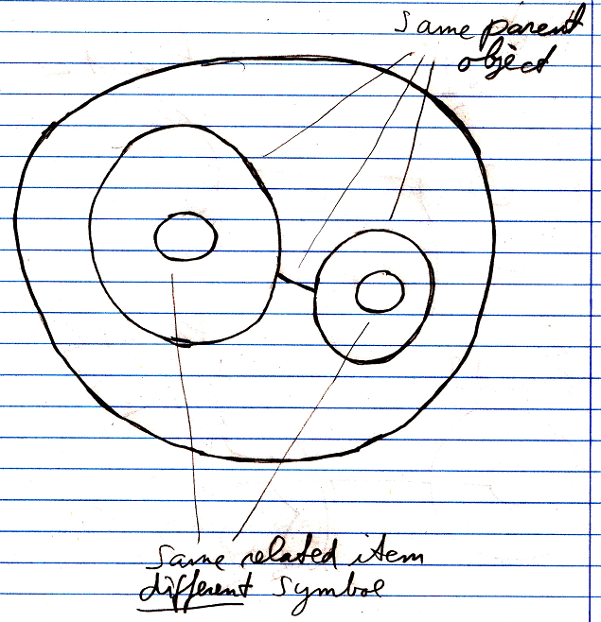

In that case multiple symbols are there for the same related item or related list item. So a symbol is a separate entity.

The term symbol was once confused as being a synonym for related object or object reference. Try not to use the term sub-symbols either. You never reference a specific symbol. A symbol is not a system element, it is just a shape displayed on screen. Symbol isn’t even a coding concept. It is a diagram expression concept. So it doesn’t even belong in this documentation section. But it has to be mentioned here, so you won’t misuse the term.

If the term symbol was synonymous for related item, then the idea that opening up a symbol’s system interface:

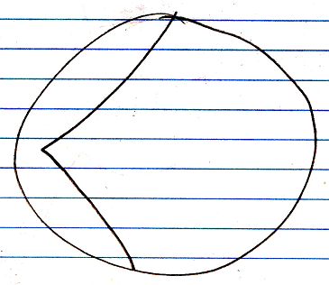

was like opening up the inner workings of a symbol. (See the article System Interface.) And the system interface was supposed to be part of the symbol, rather than part of the object itself:

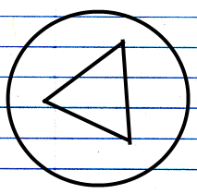

It being that you are not opening up the inner workings of a symbol, but opening up the inner workings of a related item, sort of ruins that a little bit.

But the notation for opening up the system interface still works ok and is still a clear expression.

See also: System Objects

Author & Copyright: Jan-Joost van Zon Date: July 18, 2008 – July 23, 2009 Location: Oosterhout, The Netherlands Status: Finished

